Tealen Davis

Dr Sanders

ITEC 325 - 101

14 May 2023

# NAME OF PROCEDURE: Windows 10 User Account Creation

# PRINCIPLE

**The purpose of a Standard Operating Procedure (SOP) for User Account Creation is to provide the step-by-step process of creating new user accounts on your computer. Perhaps you are managing your company’s user accounts and you need to assign specific privileges to certain users. You wouldn’t want your Finance department to have access to the same software that your Sys Admin department has. Every department has their own needs and providing privileges allows us to control who has access to what. So, let's get started!**

# SPECIMEN

# In an operating system, a user account is a particular set of settings and privileges connected to a single user or group of users. To authenticate the user and manage access to the operating system's resources and capabilities, each user account has a special username and password. A user's user account is created so that when they log into an operating system, it gives them access to a number of functions and resources, including files, folders, applications, settings, and system preferences. User accounts can be tailored to offer various degrees of access and privileges, such as restricted access for guest users or administrative access for system administrators.

# PROCEDURE

In this SOP you will be doing the following:

### Configure Administrator account

### Create Local user account

### Add user accounts to built-in “Power Users” group

## Configure Administrator Account

First thing you want to do is open your Windows search bar and type “This PC” and then proceed to “Manage”. This will bring up a tool called Computer Management. In there, you will find a plugin folder for Local users and Groups. The “User” folder is where you actually create the accounts.

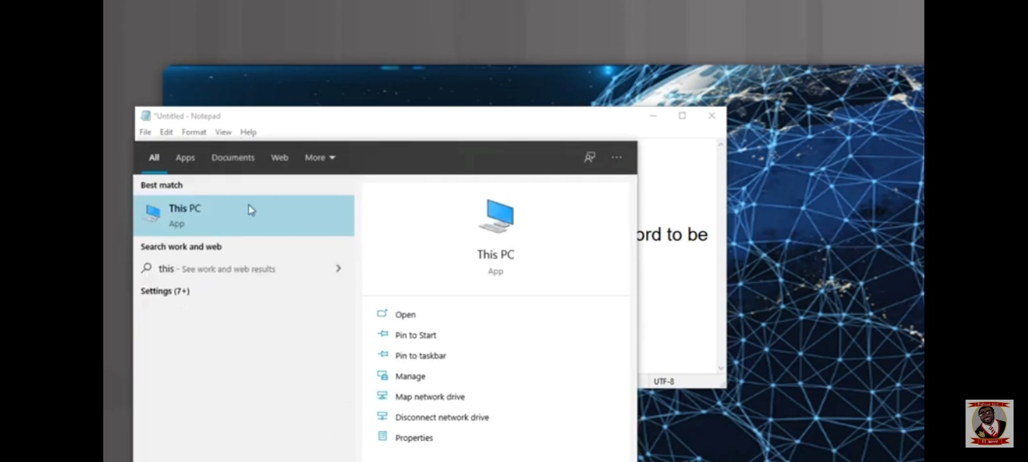

Currently, all if your accounts likely have a black arrow next to their names, which indicates that they aren’t currently turned on. Click on the user account labeled Administrator and assign it a password.

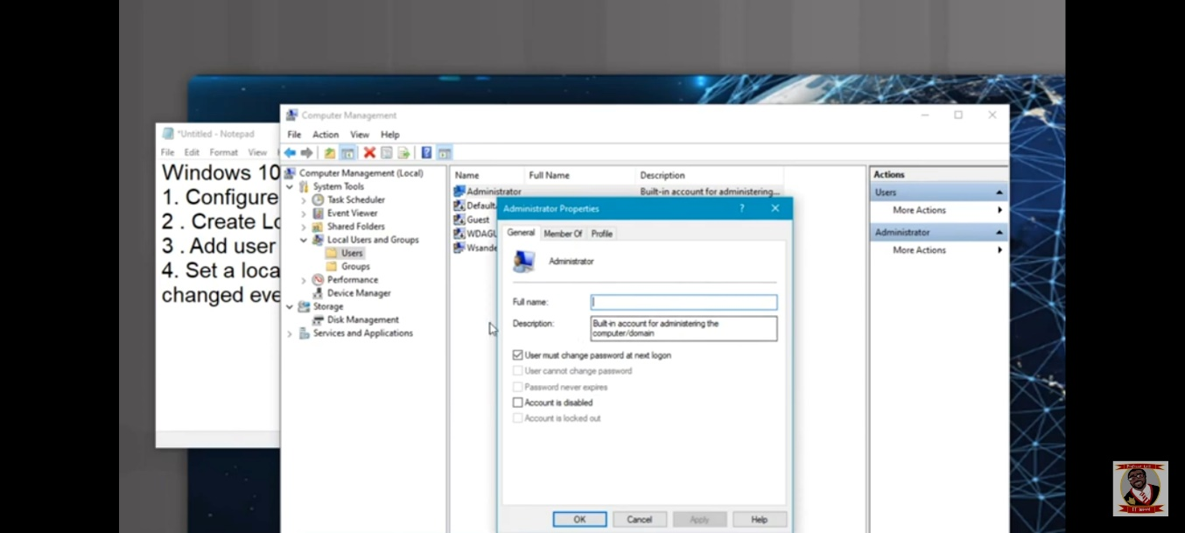

## Create Local user account

### At this point you are still in the “User” folder.

### First you want to right click anywhere within the menu of the Computer Management graphical user interphase and select “New User”.

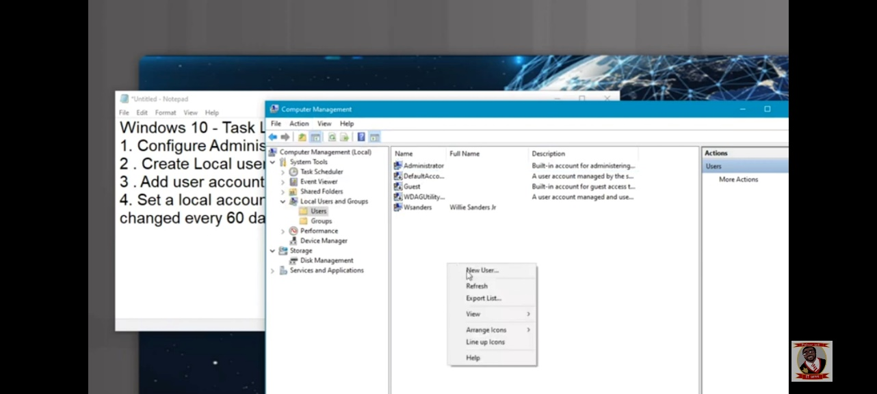

### Then under the “Actions” menu, type in the User name, Full name, description, and password for your User. Select “Create” to create the user account.

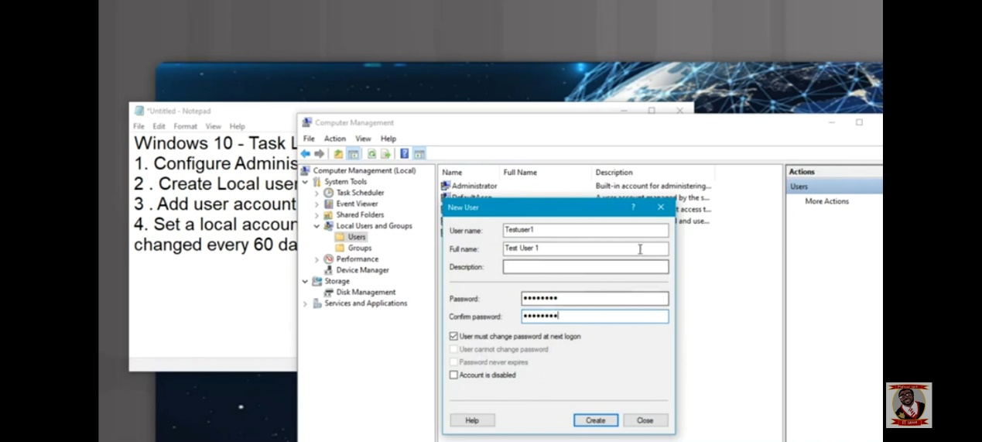

## Add user accounts to built-in “Power Users” group

At this point we are still in the “User” folder. To start off, you want to:

### Right-click on the newly created user account and select "Properties".

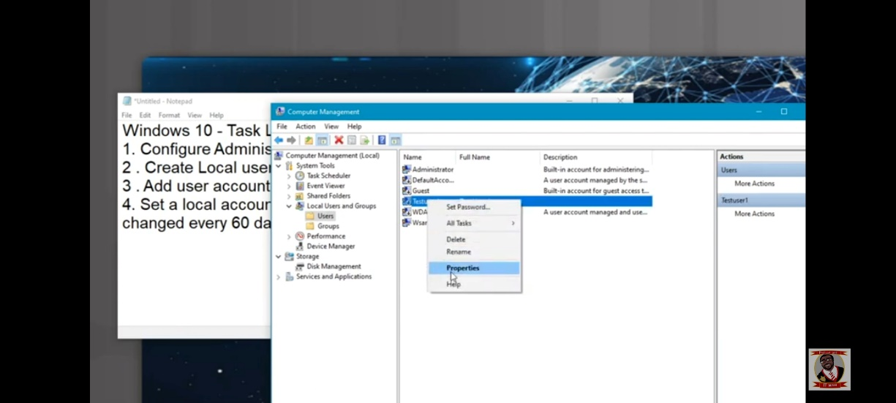

### In the Properties window, click on the "Member Of" tab.

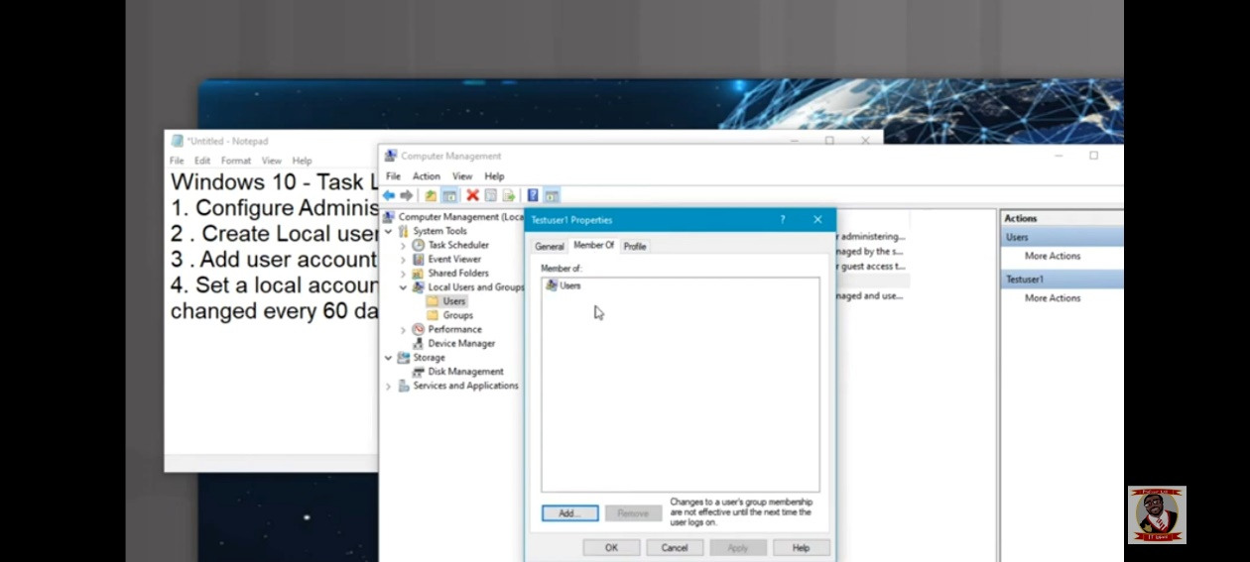

### Click the "Add" button to add the user to a group.

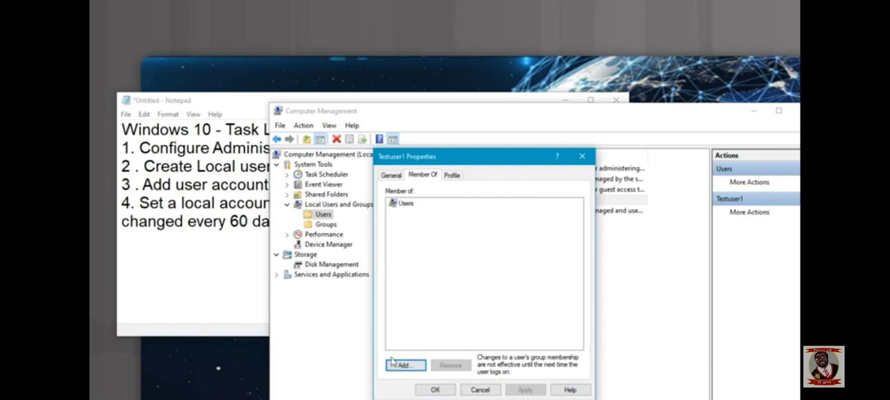

### Select “Advanced” and then click “Find now”. From there, you can click on the desired group from the list and click "OK" to join that user to the group. At this point you should have Power Users in your *Members of* tab from **Step 2**. Repeat these steps to add additional groups.

